The interior, as Chaplain Chevers knew it, was quite plain. None of the stained glass windows were installed until the ministry of Robert Herrick, the second chaplain, whose tour lasted until 1890.

In 1954, the second front Casemate was added to the Chapel as a Religious Center to house the Sunday School and other parish activities. This Chapel Center is made up of 31 rooms which once were casemate gun positions and powder magazines. They include Sunday School Classrooms, conference rooms, offices, a fully equipped kitchen, a museum, a library, and the Chevers Memorial Chapel which seats seventy.

In 1968 extensive work was done to preserve the historic chapel. The entire building was raised and a new foundation was built. Steel rods were used to support the walls which were sagging from the weight of the heavy slate roof. The balcony was extended about 3 feet to more adequately accommodate the choir.

In 1977 the last of the stained glass windows were installed. The two windows in the vestibule were given in memory of those who served in Vietnam.

A pipe organ was installed early in the 1930’s but it was destroyed by fire in 1933. It was replaced that same year and this new organ served the needs of the congregation until 1962. In 1958 some new pipes were added and in 1963 the whole organ was removed and rebuilt. It was reinstalled and rededicated early in 1964.

The organ was again totally rebuilt and dedicated on Cornelius the Centurion Day, 4 February 1983. It is a Moeller 2 manual and pedal organ of three divisions, Great, Swell and Pedal, with 13 ranks for a total of 845 pipes.

In recognition of its historical value, the chapel was added to the National Register of Historic Landmarks in 1961. It continues to serve as a house of worship for the Fort Monroe Community.

FM Pamphlet 165-1 18 Sep 85

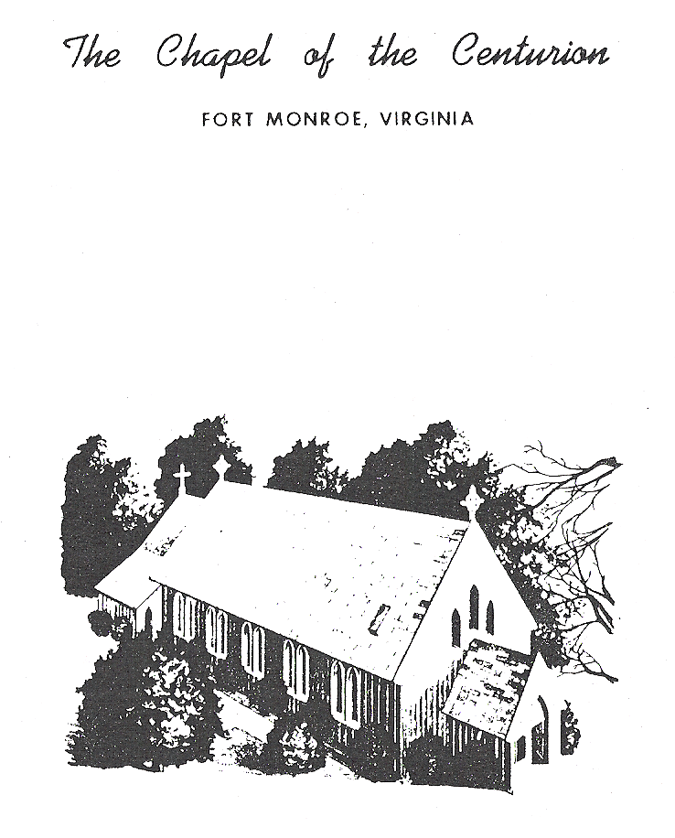

RELIGION AND FORT MONROE

The story of religion at Fort Monroe had its beginning when the rector of historic St. John's Episcopal Church of nearby Hampton, Virginia, offered his services to provide divine worship for the Garrison. There is no way of establishing the exact date of this event. The Reverend Mr. Mark L. Chevers became Rector of St. John's in 1826. Less than a year later, the members of the church petitioned the Post Commander to encourage him to spend more time with the parish. His services for the military, therefore, must have begun shortly after his arrival in Hampton.

For many years, Chevers performed a dual ministry, but there is little doubt his real love was the Army Garrison across the bay from his parish. For years he kept the vital statistical records of both at the Fort. Consequently, when Congress made provision for Post Chaplains' in 1838, he lost no time in applying for the position at Fort Monroe. In those days a chaplain remained a civilian and received a captain's pay of forty dollars plus "four rations," fuel and quarters. A special Army Regulation issued that same year guaranteed him a house for his family.

Mark Chevers became the first clergyman to hold services at Fort Monroe and its first chaplain. His tour of duty covered a lot history. He saw Black Hawk and his braves come and go. Lieutenant Robert E. Lee, West Pointer and brilliant young career officer, was a member of his congregation. He called on the illustrious prisoner, Jefferson Davis, in his casemate cell. He was Post Chaplain when an explosion at the Arsenal on Ingalls Road took two lives but left one man miraculously untouched. And when that one man made his thanksgiving in the form of a Chapel for Fort Monroe, he had for the first time in over thirty years a church in which to conduct services. Until now his congregation had worshipped in a casemate.

Mark Chevers and his wife celebrated their Golden Wedding in the Chaplain's House on Bernard Road in October, 1874. A year later, after almost half a century as Chaplain of Fort Monroe, he died in service. He was buried in the family plot in the cemetery of St. John's Church in Hampton.

One of the oldest land-marks of Fort Monroe, long the home of the Coast Artillery, is the ante-bellum chapel designed by Richard Upjohn and dedicated on 3 May 1858 as a non-denominational "church" for the Army. This was long before the concept of Army owned inter-faith chapels. The gift of members of the congregation, the "Church of the Centurion" was erected due to the efforts of Lt. Julian McAllister, the sole survivor of the arsenal accident. He was also the principle donor to the degree that he provided most of the funds.

Originally a member of the Second Artillery and a veteran of that unit in the War with Mexico, Lt. McAllister was transferred to Ordnance in 1848 and was assigned to the Arsenal at Fort Monroe in 1853. The explosion was in 1856. In 1857, before the chapel was completed, he was transferred to Richmond, Virginia; and in 1858, before it was dedicated, he was sent to California where he remained, except for the war years, until 1884 when he went to his last command, New York Arsenal, New York City.

MEMORIALS IN THE CHAPEL

Others saw to the completion of his beloved Chapel but he kept his interest in it all his life. The first memorial, a part of the original structure, was the Credence table, given in memory of an infant son who had died in 1850. One of the prie-dieux (kneelers) on the right side of the chancel was given by Capt. McAllister in memory of his wife who died in 1862 at the age of 32. The memorial vases, now in the Chevers Memorial Chapel in the Chapel Center were given in memory of a second son who died 22 November 1863, at the age of ten. His own memorials are a window on the left side of the nave, and a plaque erected in 1962 by the Senior High Fellowship by the front door of the Chapel. Col. McAllister, commander of the New York Arsenal, died in New York City on 3 January 1887.

The Chapel of the Centurion, as dedicated, was far different from the house of worship now familiar to the thousands who have seen it at Fort Monroe. It was painted dark green with a red trim, a color combination which lasted until the advent of Army Field Forces' Headquarters--fore-runner of the Continental Army Command. At that time the "newcomers" outraged the remaining coast artillery people by painting their beloved chapel its present white. The old-timers referred to it unhappily as the "chicken coop."

